

KURO – Information for invitation to tender

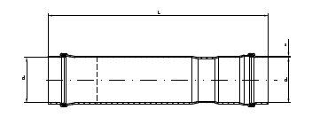
Product:

PVC double sealing socket for expansion

Information for invitation to tender:

 | Pos:....................... | PVC double sealing socket for expansion
 |  | Colour: black 50 x 1,8 mm / Length= 340 mm
 |  | System KURO o. glw. (www.kuro-kunststoffe.de),
 |  | supply and install, as an addition to pos: ...........
 |  | Amount:............Pieces UP: ....... TP: ........
 | Pos:....................... | PVC double sealing socket for expansion
 |  | Colour: black 110 x 3,2 mm / Length= 540 mm
 |  | System KURO o. glw. (www.kuro-kunststoffe.de),
 |  | supply and install, as an addition to pos: ...........
 |  | Amount:............Pieces UP: ....... TP: ........

